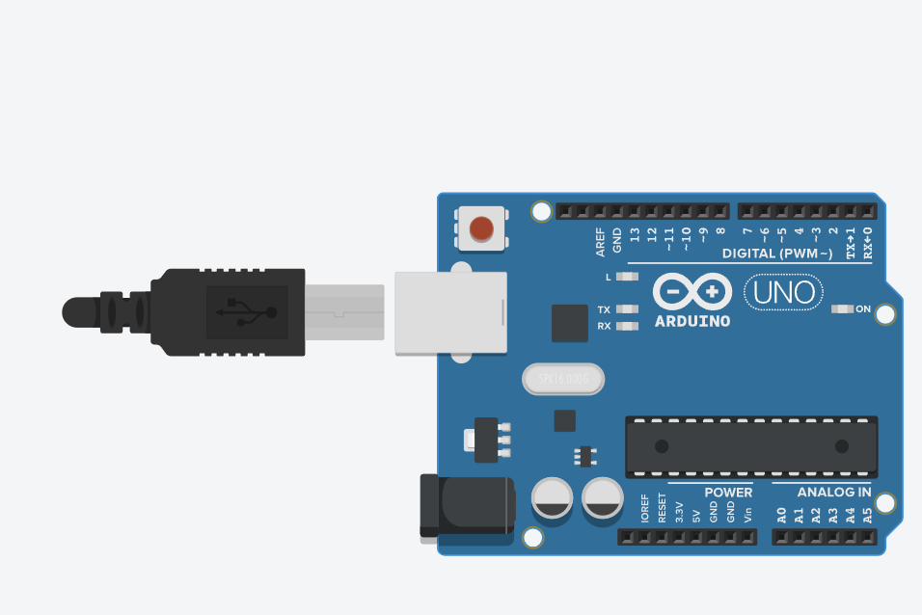

int number;

int squaredNumber;

void setup() { Serial.begin(9600);

Serial.println("Enter a number:");

}

void loop() {

if (Serial.available() > 0) { number = Serial.parseInt();

squaredNumber = number \* number;

Serial.print("You entered: "); Serial.println(number);

Serial.print("Squared value: "); Serial.println(squaredNumber);

Serial.println("Enter another number:");

}

}